
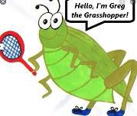
Lyng Primary School P.E Knowledge Organiser
Topic: Football | Year 6 | Autumn 1


“There is no pressure when you are making a dream come true” – Neymar Jr
Enquiry Questions
- How can we improve ball control and ability to travel with the ball at speed?
- How can we dribble past an opponent?
- How can different types of control help us in attacking scenarios?
- How can I improve my weaker foot when shooting?
- What pressure should I apply to a player from an attacking team in a defending scenario?
- How can we combine skills we have learnt into game play?

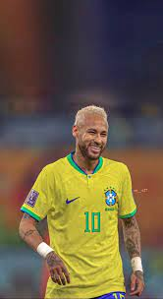

Key words
Spelling | Definition
Attacker | Main contribution of an attacker is to focus on creating or taking key opportunities.
Offside | When an attacking player is beyond the last defender of the defending team when the ball is passed to them.
Dribbling | To move whilst in possession of the ball at your feet.
1-2 | A two pass combination between players to get around a defender.
Control | Control could be your first touch when receiving the ball or maintaining control of the ball when dribbling/shooting.
Possession | Retain the ball for the team, so your team is in control and have the ball.
Indirect free kick | When a free kick is awarded where the attacking team cannot shoot direct at goal another player must make contact with the ball first.
Tactics | Methods that you choose in order to be successful, i.e. number of passes made, movement, defensive/offensive shape.
Defender | Main contribution to the team is to prevent goals and protect the goalkeeper.

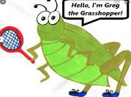
Lyng Primary School P.E Knowledge Organiser
Topic: Football | Year 5 | Autumn 1

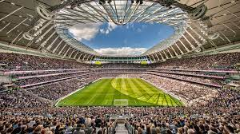
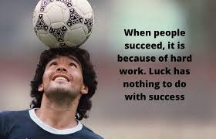
Learning outcomes:

- To develop different types of turns
- To show confidence and put into practice different dribbling techniques
- To show different types of passes and ways to receive the ball
- To develop different shooting styles against an opponent.
- To improve our body shape when defending.
- To combine skills and practices into a game scenario

